PAINT OUT PROGRAM 2024
The GECAG Paint-outs take place on the first Saturday of the month. The meeting time is at the venue is 10.00am. The painting session will generally conclude by midday.
Participation in the Paint-outs is free. Participants are asked to register on Trybooking by midday on the Friday before the scheduled paint-out.
It is expected that the Paint-out will go ahead regardless of the weather, as some shelter can be found at most locations. If there are any changes to arrangements to the Paint-out then registered participants will be sent a text message at 8.00am on the morning of the Paint-out advising them of the change.
If you have any questions or would like further information please contact Isabelle McKenzie, idmckenzie1@gmail.com or 0490 114 196.
Date |  | Location | Meeting Point
Saturday February 3 | 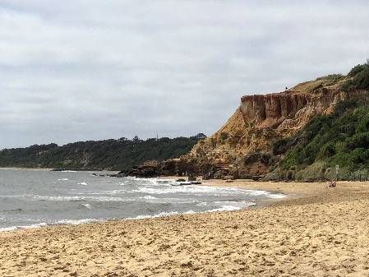 | Red Bluff, Cerberus  Beach, cliff, buildings | Cerberus Beach House at 10.00am, near Black Rock Yacht Club
March 2 | 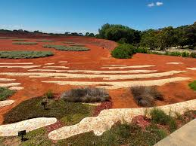 | Cranbourne Botanical Gardens, cnr Ballarto Road and Botanic Drive. | We will endeavour to arrange car pooling as this is about 40 minutes drive from Bentleigh. More details closer to the date.
April 6 | 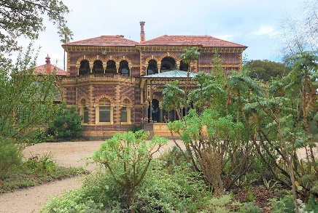 | Ripponlea Historic house, gardens, lake | Meet at gate at 10.00am when gate opens (192 Hotham Street Elsternwick. There is a café inside the property.
May 4 | 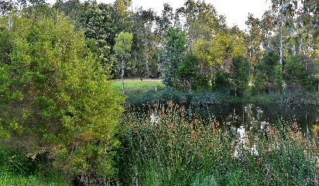 | Namatjira park  Yabby pond, bush | Meet at car park in Raleigh Street, Clayton South at 10.00am
June 1 | 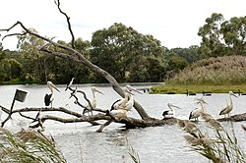 | Braeside Park, lake, bushlands, | Meet at Red Gum Picnic area at 10.00am, enter from Governor Road N.B. no café here
July 6 | 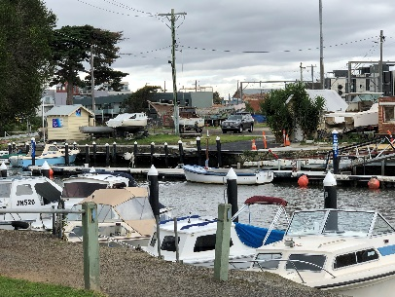 | Pompeii’s Landing, Mordialloc, creek, boats, trees | Meet at Attenborough Park at 10.00am (left hand side of Nepean Highway after crossing Mordialloc Creek heading South.
August 3 | 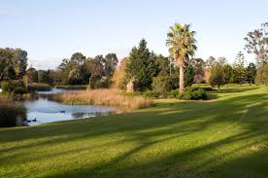 | Basterfield Park Hampton East, lake, playgrounds, trees, | Park near Tennis Court and meet lakeside at 10.00am
September 7 | 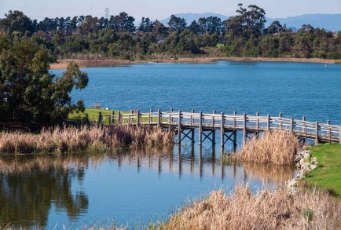 | Karkarook Park, lake, picnic areas and bushland | Meet at Dragonfly picnic area meet at 10.00am. N.B. no café at Karkarook Park.
October 5 | 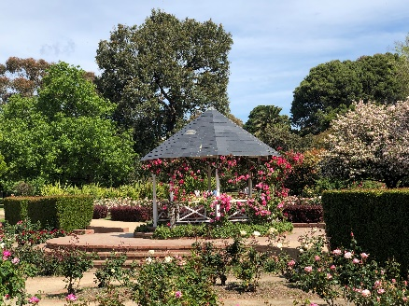 | St Kilda Botanical Gardens, Herbert Street, St Kilda -trees, gardens, pond | Meet at Ornamental Pond at 10.00am. N.B. there is no café in the Gardens,
November 2 | 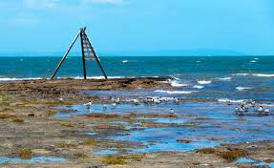 | Rickett’s Point Beach, cliff, brush | Meet at Rickett’s Point café at 10.00am

